EBS Volume Management And Backup Strategies

Partition:
a partition is a logical division of a physical storage device
- partition makes backing up easier
- separating the user data from the system data
- also used for organising the data
- To improve the security and stability
- To use different filesystems (like ext4, NTFS, etc.)

Common Linux partitions
- / (root)
Main partition where the OS is installed
- /home
Stores user files and personal data
- swap
Used as virtual memory when RAM is full
- /boot
Contains bootloader and kernel files

Example
A 500GB disk could be divided like:
- 100GB → / (system)
- 350GB → /home (user data)
- 50GB → swap

Types of partitions
- Primary partition – main partition (bootable)
- Extended partition – container for logical partitions
- Logical partition – subdivisions inside extended

Note:
- we can create up to 4 partitions
- out of 4 partitions, 3 are primary partitions and 1 is extended partition also we can create all 4 partitions as a primary partition but only in MBR

How Linux identifies partitions
Linux names them like:
- /dev/sda → whole disk
- /dev/sda1, /dev/sda2 → partitions

Practical: Create a Partion of the volume
1.create a instance
- Name -------------> webserver
- Ami ----------------> amazon linux
- Instance type ---> t3. micro
- Key name --------> ubuntu
- Create a instance

2.Create A Volume Of 10GB
- Create a volume – 10GB
- Availability zone – 1a
- Create a volume

3.Attach volume to a instance
- Click on the volume
- Attach a volume
- Availability zone – 1a
- Instance – webserver
- Device name - /dev/sdb
- Attach volume

4.Create a partition of the volume & mount the volume
- Access the instance
- Create a partition
- lsblk
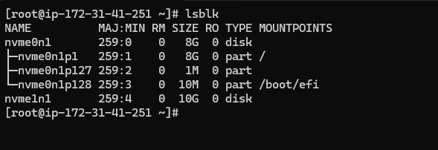

Note:
- nvme0n1 (8G) -------> system volume / disk
- nvme0n1p1 ----------> system partition
- nvme1n1 (10G) -----> Extra attached volume

- create a partition
fdisk /dev/nvme1n1
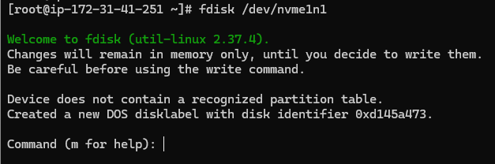

- press m ---> (for help)
- press n ----> (for create a partition)
- press p ----> (for create a primary partition)
- press 1 ----> (for creating a first partition)
- first sector -> Empty
- last sector --> +4G
- press w -----> (for saving the partition table)
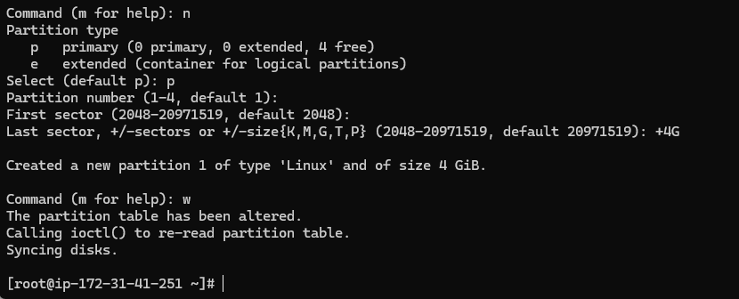

- lsblk
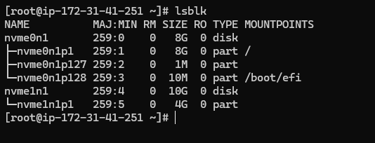

- Create 2nd partition
- fdisk /dev/nvme1n1
- press m ---> (for help)
- press n ----> (for create a partition)
- press p ----> (for create a primary partition)
- press 2 ----> (for creating a 2nd partition)
- first sector -> Empty
- last sector --> +4G
- press w -----> (for saving the partition table)

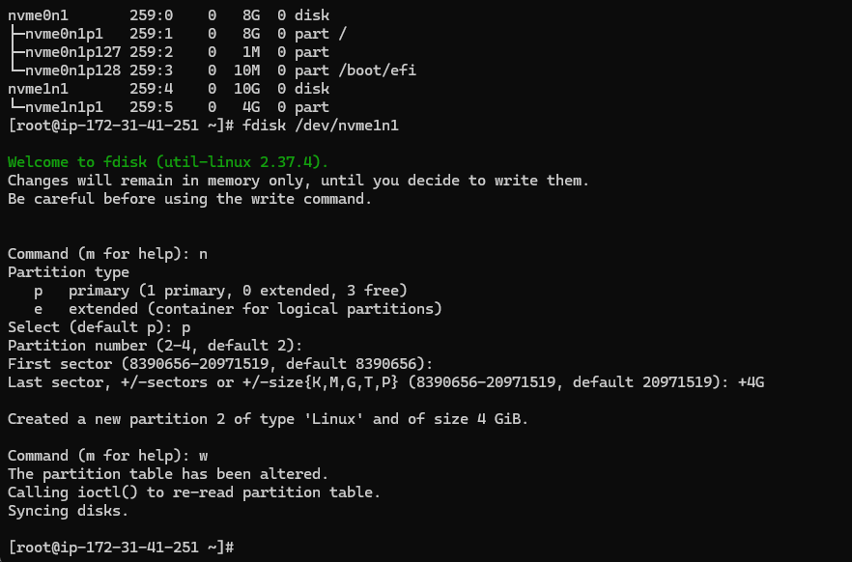

- lsblk
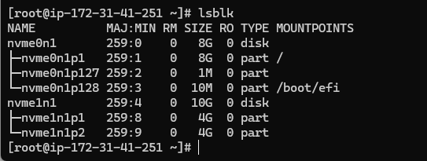

Note:
- nvme1n1 ----------> attach disk (10GB)
- nvme1n1p1 -------> partition1 (4GB)
- nvme1n1p2 -------> partition2 (4GB)

- Assign a filesystem to partition
mkfs.ext4 /dev/ nvme1n1p1
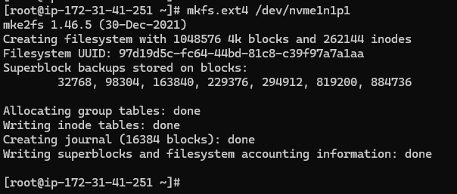
- To check the filesystem, assign or not
1.blkid
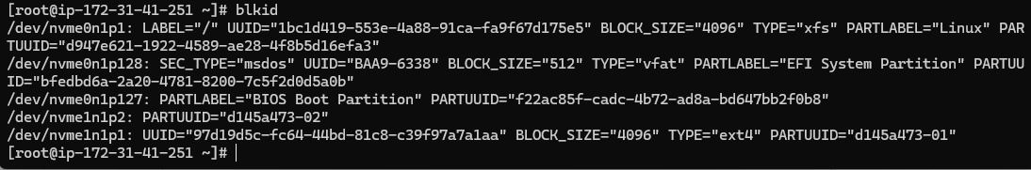

- Mount the partition (Temporary Mounting)
1.mount /dev/nvme1n1p1 /mnt
- lsblk
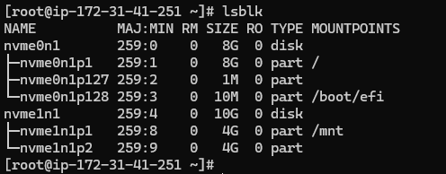

- To check disk space usage along with filesystem types
1.df -Th
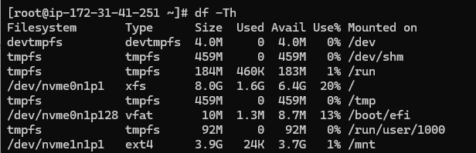
Note:
- At this time, we mount the partition temporary to mnt
- After reboot, it will disappear.

PERMANENT MOUNTING
1.blkid
{Copy the UUID of nvme1n1p1 from your partition}
2.vim /etc/fstab
UUID=97d19d5c-fc64-44bd-81c8-c39f97a7a1aa /mnt ext4 defaults 0 2
3.cat /etc/fstab
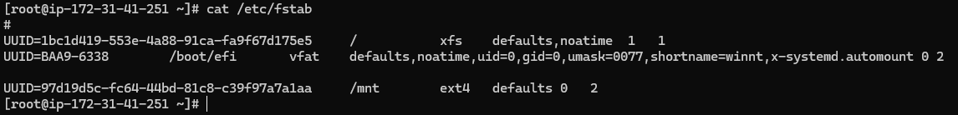
4. Update The Partition
mount -a
5.lsblk
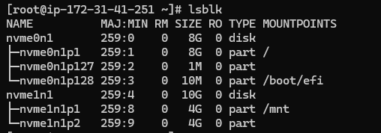

Note:
- UUID=abcd-1234 → your actual UUID of Partition
- /mnt → mount point
- ext4 → filesystem
- 0 → no dump
- 2 → correct for non-root partition (priority)

Explanation:
1.Why we use 0 In permanent mounting (Dump / Backup)
- 0 → Do NOT take backup
- 1 → Take backup (rarely used today)
{Everyone uses the almost 0 because modern systems use other backup tools}
2.Why we use 2 when permanently mounting the partition
- 0 ---------> Do not check
- 1 ---------> Check First (root /)
- 2 ---------> Check After root
After system starts
- Root partition (/) is checked first → 1
- Other partitions (like /mnt) are checked later → 2

SIMPLE STEPS TO CREATE A PARTITION
- create a partition (fdisk)
- attach a filesystem (mkfs)
- mount the partition (mount)
- check the disk usage (df -Th)

COMMANDS
- fdisk -------> Used to create, delete & manage the disk partitions on system
- mkfs -------> Used to assign a filesystem to a new partition
- blkid -------> Shows UUID and filesystem type of partitions
- lsblk -------> Shows all disks and partitions in tree format
- mount ----> Used to attach a partition to a directory
- df -Th -----> Shows disk usage along with filesystem type

DIFFERENCE BETWEEN THE EXT4 & XFS

EXT4 FILESYSTEM
ext4 = Old, stable, widely used filesystem
- Best for small to medium files
- Very stable & reliable
- Supports journaling (prevents data loss)
- Easy to recover & repair
- Slower with very large data
- Example: OS disks, small applications, general usage

XFS FILESYSTEM
xfs = High-performance filesystem
- Best for large files & big data
- Very fast performance
- Supports parallel I/O (multi-threading)
- Scales well for large storage
- Hard to shrink filesystem
- Recovery is more complex than ext4
- Example: Databases, logs, big storage servers

Note:
- ext4 = Safe + Stable
- xfs = Fast + Powerful

DIFFERENCE BETWEEN THE MBR AND GPT

MBR (Master Boot Record)
MBR = Old partition system
- Supports only up to 4 partitions
- Maximum disk size: 2 TB
- Stored in one location (risk if corrupted)
- Works with older systems (BIOS)

GPT (GUID Partition Table)
GPT = Modern partition system
- Supports 128 partitions (or more)
- Supports very large disks (more than 2 TB)
- Has backup (more safe)
- Works with modern systems (UEFI)

SNAPSHOT
- Snapshot is a point in time copies or point in time images of our EBS volume
- With the help of snapshot, we can take easily backup of our EBS volume
- EBS volumes are AZ specific While the Snapshots are region specific
- Using snapshots, we can create a new EBS volume in any Availability Zone (AZ) within the same region.
- As well as we can also share the snapshot from one account to another account
- In AWS, we can create up to 10,000 EBS snapshots per region. (By Default)
- Snapshots are incremental data backups
- Any data written in the EBS volume after the snapshots should not be included. It will be included after the incremental updates (means after taking another snapshot)
- EBS snapshots are stored on Amazon S3, however you cannot access them directly you can only access them through EC2 APIs.
- you can create a snapshot to an EBS volume of the same or longer size than the original volume size, from which the snapshot was initially created. But we can’t create the EBS volume less than the actual size of the snapshots.

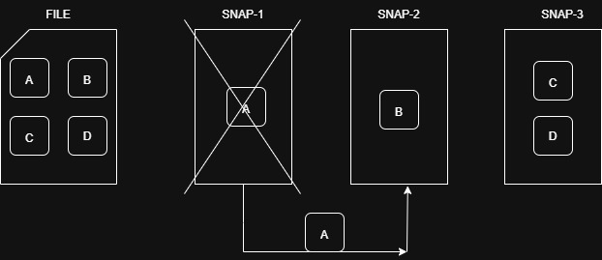

TAKE BACKUP OF EBS VOLUME (Manually)
1.Create A Instance
- name --------------> webserver
- ami -----------------> ubuntu
- key name ---------> ubuntu.pem
- create a instance

2.Create A Snapshot
- go to volume -> click on volume -> create a snapshot
- resource type -> volume
- description -> my root volume snapshot
- create a snapshot

3.Click On Snapshot
1.click on snapshot
{You can create a image as well as volume from these snapshot}

TAKE BACKUP OF EBS VOLUME (automatically)
1.Go To Lifecycle Manager
- create lifecycle policy -> custom policy
- Target resource types -> instance
- Target resource tags
  - key -> Name
  - value -> ubuntu
- 3.policy status -> enabled
- Frequency -> Daily
- 5.Every -> Hour
- Starting at -> 9:00
- Retention type -> 10
- Review policy

HOW TO COPY SNAPSHOT FROM ONE REGION TO ANOTHER REGION
1.click on snapshot
- click on action
- click on copy snapshot
- Destination Region -> ap-southeast-1
- Copy snapshot

2.Go to Singapore region
- click on snapshot
- you get the snapshot

HOW TO SHARE SNAPSHOT FROM ONE ACCOUNT TO ANOTHER ACCOUNT

1.Click On Snapshot
- click on actions
- Snapshot setting -> Modify permissions
- Sharing options -> private
- Add account -> enter another account ID
- Click on these account ID
- Modify permissions

Tasks:
- How to create a ami from snapshot
- How to create a volume from snapshot in another AZ
- How to copy snapshot from one region to another region
- How to share snapshot from one account to another account
- Create a ami of existing instance and create a new instance from these ami
- Attach a new volume to instance, mount this volume and create some data in this volume, then detach this volume and create a new instance and attach this volume to new instance and mount this volume and verify whether the data persists.
- Create a snapshot of a volume, delete the volume, create a new volume from the snapshot, attach it to an instance, and verify the data.

